A Report on Major project

Data Driven Pune Municipal Corporation (PMC) Traffic Analysis System
SUBMITTED IN PARTIAL FULFILLMENT OF THE REQUIREMENTS FOR THE DEGREE OF

BACHELOR OF TECHNOLOGY IN
COMPUTER ENGINEERING OF
VISHWAKARMA INSTITUTE OF TECHNOLOGY

Savitribai Phule Pune University

BY

Ajinkya Walunj (GR No. 12110283)
Akash Bhandari (GR No. 12111450)
Anish Sagri (GR No. 12110206)
Annany Dev Singh (GR No. 12110296)

UNDER THE GUIDANCE OF

Dr. Radhika Kulkarni.


DEPARTMENT OF COMPUTER ENGINEERING

BANSILAL RAMNATH AGARWAL CHARITABLE TRUST’S
VISHWAKARMA INSTITUTE OF TECHNOLOGY
(An Autonomous Institute affiliated to Savitribai Phule Pune University)
PUNE - 411037
2024 - 2025

BANSILAL RAMNATH AGARWAL CHARITABLE TRUST’S
VISHWAKARMA INSTITUTE OF TECHNOLOGY
(An Autonomous Institute affiliated to Savitribai Phule Pune University)
PUNE – 411037

CERTIFICATE

This is to certify that the Major Project titled Data Driven Pune Municipal Corporation (PMC) Traffic Analysis System submitted by group members Ajinkya Walunj (GR No. 12110283), Akash Bhandari (GR No. 12111450), Anish Sagri (GR No. 12110206), Annany Dev Singh (GR No. 12110296) in partial fulfillment for the award of Degree of Bachelor of Technology in Computer Engineering of Vishwakarma Institute of Technology, Savitribai Phule Pune University. This Major Project is a record of bonafide work carried out by them under my guidance during the academic year 2024-25.

Guide Head
Dr. Radhika Kulkarni Prof. Dr. S. R. Shinde

Department of Computer Engineering

Sign of External Examiner Date

Bansilal Ramnath Agarwal Charitable Trust’s
Vishwakarma Institute Of Technology, Pune-37
Department Of Computer Engineering

PROJECT SYNOPSIS

Group No: A - 14 Group Members:
Roll No | Name | Class | Contact No | Email-ID
05 | Ajinkya Walunj | B. Tech | 8010535969 | appaji.ajinkya21@vit.edu
06 | Akash Bhandari | B. Tech | 8080685936 | vinayak.akash21@vit.edu
11 | Anish Sagri | B. Tech | 7666729431 | anish.sagri21@vit.edu
13 | Annany Dev Singh | B. Tech | 9103148147 | annanydev.singh21@vit.edu

Academic Year : 2024-2025
Project Title : Data Driven Pune Municipal Corporation (PMC) Traffic Analysis System
Project Area : AI-ML, Web Technology
Sponsor Company : Pune Municipal Corporation (PMC)

Company Address : Pune

Internal Guide : Dr. Radhika Kulkarni

Name of the External Guide:
Contact No:

Signature of Internal Guide

ACKNOWLEDGEMENT

We express our deepest gratitude to Mr. Rahul Jagtap, IT Head of Pune Municipal Corporation, for his invaluable guidance and support throughout this project. His expertise and insights were instrumental in shaping our approach and ensuring the project’s relevance to real-world applications. We are profoundly thankful to our project guide, Dr. Radhika Kulkarni, for their continuous mentorship, constructive feedback, and encouragement, which greatly contributed to the successful execution of this project. We also extend our heartfelt thanks to Dr. Amar Buchade and Dr. Tushar Mote from IEEE Pune Chapter Smart City Section, for their unwavering support and assistance, which provided us with the necessary resources and motivation during critical phases of the project. A special acknowledgment goes to Prof. Rakhi Bhardwaj, whose invaluable suggestions and constructive evaluations enriched the quality of this work. Lastly, we are sincerely grateful to our esteemed Head of Department, Prof. Dr. Sandeep Shinde, for their guidance, encouragement, and for providing us with the opportunity to undertake this project. We owe the success of this endeavor to the combined efforts and support of all individuals.

Ajinkya Walunj
Akash Bhandari
Anish Sagri
Annany Dev Singh

INDEX

Sr.no. | Table of contents | Pg. no
1 | Software Project Synopsis | 7
2 | Feasibility Status Report | 9
3 | Use Case Analysis Document | 16
4 | Software Requirements Specification | 18
5 | Software Project Plan | 20
6 | Software Implementation Document | 22
7 | Conclusion | 38
8 | References | 39

Sr. no. | List of figures | Pg. no
6.1.1 | Architecture of Proposed System | 25
6.1.2 | Data Flow Diagram | 25
6.1.3 | System Architecture | 26
6.2.1 | GitHub repository for Frontend | 27
6.2.2 | GitHub repository for Backend | 27
6.3.1 | Home Page | 29
6.3.2 | Reward Page | 29
6.3.3 | Pothole Registration Page | 30
6.3.4 | Complaint Registration Page | 30
6.3.5 | Route Analysis Page (State-1) | 31
6.3.6 | Route Traffic Map | 32
6.3.7 | Display after clicking get route button | 32
6.3.8 | Detailed analysis for traffic | 33

Sr. no. | List of tables | Pg. no
2.2.1 | Literature Review | 10
3.1 | Use case Template | 17
5.2.1 | Project Goals | 22
6.4.1 | Result comparison of ResNet-50 and Mobile-Net on Pothole Dataset | 33
6.4.2 | Functionality and corresponding APIs used | 33
6.4.3 | Optimization for Nearby Places functionality and corresponding result | 34

Software Project Synopsis

Approvals Signature Block

Project Responsibility | Signature | Date
Project Guide (Internal)
Project Guide (External)
Documentation Leader

1. CONTEXT

In rapidly urbanizing cities like Pune, road congestion, poorly maintained infrastructure, and inefficient management of public spaces are recurring challenges that significantly affect daily commuting. The lack of accessible systems for reporting infrastructure issues, such as potholes or traffic hotspots, leads to delays in repairs and contributes to unsafe travel conditions. This issue is further exacerbated by unplanned events or gatherings on roadways, as well as sudden traffic surges around educational institutions during opening and closing times. Without a centralized system to report, analyze, and address these factors, both commuters and city authorities struggle with unpredictable traffic patterns and infrastructure strain, impacting the quality of life and urban mobility.

2. PROBLEM

The recurring issue faced by commuters and local authorities is the absence of an integrated platform to systematically report and analyze road conditions, events, and traffic influencers in real time. Citizens have limited channels to report potholes, infrastructure complaints, or event permissions, resulting in delayed responses and poor road conditions. Additionally, there is a growing demand for a route-analysis tool that considers multiple factors influencing traffic beyond just live congestion data. Without such a system, both citizens and municipal authorities lack actionable insights into road safety, traffic efficiency, and maintenance needs, which ultimately leads to inefficient urban management, unpredictable delays, and compromised road safety.

3. SOLUTION

The PMC Traffic Analysis Portal addresses these challenges by providing interactive platform for real-time traffic analysis and infrastructure reporting. The system empowers citizens to report potholes and road complaints via image uploads, with issues verified through a machine learning model, and to request event space permissions in specific road-adjacent areas. Its "Analyze Route" feature offers a comprehensive view of route conditions, incorporating data such as traffic status, potholes, complaints, events, and the presence of nearby schools or colleges with opening and closing times close to the current time. By providing a traffic score and actionable insights on route safety and efficiency, the portal not only enhances the commuting experience for users but also supports city authorities in proactively managing road maintenance and traffic control, thereby contributing to safer, more sustainable urban mobility.

Feasibility Study Report

Approvals Signature Block

Project Responsibility | Signature | Date
Project Guide (Internal)
Project Guide (External)
Documentation Leader

- PURPOSE

The purpose of this traffic analysis project is to develop an efficient solution for monitoring urban traffic flow, road safety, and congestion in rapidly growing cities like Pune. Existing traffic management solutions often lack the ability to address location-specific issues, such as road hazards, unplanned events, and peak congestion near schools and colleges. Our goal is to provide an affordable, user-friendly platform that leverages real-time data to improve route planning and offer actionable insights for traffic management and road safety.

- CURRENT SYSTEMS AND PROCESSES

LITERATURE REVIEW

Title | Methodology | Advantages | Limitations
Potholes Detection Using Deep Learning and Area Estimation Using Image Processing | The study trained YOLOv5 (small, medium, and large) and Faster R-CNN (with ResNet50, VGG16, and MobileNetV2 backbones) on a dataset of 665 images, validated 183, and tested on 92 images. Data augmentation techniques, such as mosaic augmentation and flips, were applied to prevent overfitting. Performance was evaluated using metrics like Precision, Recall, and mAP@0.5-0.95. Area estimation used Inverse Perspective Mapping (IPM) based on camera parameters to calculate pothole areas in real-time with no loss of detection speed. | 1.Enables accurate real-time pothole detection and area estimation using efficient CNN models like YOLOv5 and Faster R-CNN.  2.Can be embedded in vehicles for warnings and repair planning, offering practical solutions with low computational cost. | 1.Performance decreases in extreme weather conditions, poor road conditions, or unusual camera angles.  2.Requires significant hardware setup for high-accuracy models like Faster R-CNN with ResNet50, limiting accessibility in low-resource environments.
RUI: A Web-based Road Updates Information System using Google Maps API | The system was developed using the Agile Model, emphasizing iterative development and user feedback. Key components include:  Design: User requirements and feedback were collected to design system architecture, database models, and interfaces.  Implementation: Developed using WordPress for the web app, PHP for backend logic, CSS for design, and JavaScript for interactivity.  Evaluation: Assessed using ISO/IEC 25010, measuring characteristics like functionality, usability, and reliability, yielding an excellent overall performance rating of 4.21 on a Likert scale. | 1.Provides real-time road updates and alerts through Google Maps API, helping commuters and drivers make informed travel decisions.  2.Enables user participation in reporting road incidents with visual proof, fostering community-driven updates. | 1.System functionality depends on internet availability, limiting accessibility in remote areas.  2.Reliance on user-generated content could lead to inaccurate or misleading reports if not properly validated.
Effect of User Interface and User Experience on Application Sales | The study employed an observation method, comparing two applications with contrasting ratings and download counts. Key aspects evaluated included interface design, ease of use, and features. The analysis focused on user interaction, including creating, editing, and deleting notes, and the impact of these factors on user comfort and application sales. | 1. Highlights the significant role of UI/UX in determining application success.  2. Provides practical insights by analyzing real-world applications with varying user ratings.  3. Emphasizes the importance of intuitive design for diverse user groups. | 1. Limited to a descriptive observation, lacking detailed statistical analysis.  2. Only focuses on two applications, which may not represent broader trends.  3. Cultural or demographic user variations were not considered comprehensively..
Performance Optimization using MERN stack on Web Application | The development of the web application utilized the MERN stack, comprising MongoDB for data storage, Express.js for server-side framework, React.js for the front-end user interface, and Node.js for runtime environment. The application follows an event-driven and asynchronous architecture for optimal performance. Chrome Developer Tools and Redux were employed for debugging and simulation during testing phases. | 1.Efficiency: Asynchronous processing optimizes server resource usage.  2. Scalability: MERN stack components enable high scalability for future growth.  3. Rapid Development: Pre-built libraries and middleware reduce development time.  4. Cross-platform Support: The stack supports deployment on multiple environments. | 1. Learning Curve: Requires expertise in multiple technologies.  2. Server Overhead: Single-threaded architecture may cause performance issues under heavy computational tasks.  3. Maintenance Complexity: Managing and updating stack components can be challenging.
Online Destinations Map using Google Maps API Based on the Private  Database | The research integrates Google Maps API with a MySQL database using PHP, HTML, CSS, and JavaScript. Geographical data (latitude and longitude) is stored in the database and retrieved via XML for enhanced user interaction and customization. | - Customization: Adds specific, localized data to Google Maps.  - Ease of Use: User-friendly graphical interface.  - Efficient Data Retrieval: Fast and reliable responses to user queries.  - Expandable: Allows future updates without system disruption. | - Data Accuracy: Reliance on local data may introduce inconsistencies.  - Complex Implementation: Requires technical expertise in multiple programming languages.  - Limited Scalability: Local server constraints may hinder handling large-scale requests.
Pros and Cons Analysis of Mern Stack Framework for Web Development | This study analyzed the MERN stack by developing sample applications, conducting performance tests, and collecting user feedback. Tools like Apache JMeter for performance testing and online surveys for user input were utilized. Data analysis included code reviews, performance metrics, and satisfaction assessments to evaluate the stack's strengths and weaknesses. | - Unified JavaScript language across the stack.  - Scalability and efficiency for real-time and data-intensive applications.  - Modular code structure with React promotes reusability.  - Strong user experience with fast navigation and intuitive interfaces. | - Steep learning curve for newcomers.  - Performance bottlenecks in CPU-intensive tasks with Node.js.  - Complex SEO optimization for React-based SPAs.  - Initial configuration and deployment challenges.
Urban traffic congestion and its association with gas station density: insights from Google Maps data | The study analyzed traffic congestion in Jakarta's 42 sub-districts using Google Maps data digitized in QGIS. A 500m grid system categorized traffic levels and summarized data weekly for a month. Gas station density was calculated by dividing station counts by sub-district areas, and correlations were tested using a Chi-square analysis. Results showed a strong relationship between high gas station density and traffic congestion. | 1.Provides detailed traffic congestion analysis at the sub-district level using accessible Google Maps data.  2.Enables policymakers to develop targeted strategies for reducing traffic-related air pollution. | 1.Heavily relies on the accuracy of Google Maps data and manual digitization, which may introduce errors.  2.Focuses solely on traffic-related air pollution, overlooking other pollution sources like industries or households.
Data-driven spatial-temporal analysis of highway traffic volume considering weather and festival impacts | The study utilized data from the Greater Bay Area (GBA), focusing on weather, traffic, and temporal variables. A random-effects regression model (RER) and a random forest (RF) model were developed to examine correlations. The RER + RF fusion model was created using ridge regression for hourly traffic prediction. Data from 2016–2019 were split into training (70%) and test (30%) sets, and results were validated using metrics like MAE and MSE. | 1.Integrates multi-source data for precise spatial-temporal traffic analysis, considering weather, temporal, and festival effects.  2.The RER + RF fusion model outperforms single models, offering high prediction accuracy for highway traffic volumes. | 1.Relies on accurate hourly data, making it less effective in areas with incomplete or lower-resolution data.  2.Focuses only on a specific time frame (January to March), limiting insights into other seasonal traffic patterns.
A deep-learning model for urban traffic flow prediction with traffic events mined from twitter | The study developed a traffic flow prediction model using a deep bi-directional LSTM stacked autoencoder. It combines traffic, weather, and real-time social media (Twitter) data to capture non-recurring events. The autoencoder reduces computational demand by compressing input data while preserving key features. | 1,Improved Accuracy: Incorporating Twitter and weather data enhanced prediction accuracy.  2.Handling Non-recurring Events: Captures irregular traffic events effectively, unlike traditional models.  3.Dimensionality Reduction: Autoencoder reduces computational overhead | 1.Data Noise: Social media data require extensive filtering and calibration.  2.Computational Demand: Deep learning models require significant computational resources.  3.Long Training Time: Inclusion of multiple data sources prolongs model training.
Deep Learning for Network Traffic Monitoring and Analysis(NTMA):A  Survey | This paper reviews the application of deep learning (DL) models in NTMA. It focuses on models like CNNs, RNNs, and LSTMs for tasks such as traffic classification, prediction, and fault management. It also addresses the challenges of analyzing high-velocity, heterogeneous network data. | 1.Enhanced Accuracy: DL techniques outperform traditional methods in traffic prediction and classification.  2.Temporal and Spatial Insights: LSTM models efficiently handle time-series and spatial data.  3.Minimal Human Intervention: Automated feature extraction reduces dependency on manual processes. | 1.Computational Demands: High-performance hardware like GPUs is essential for training models.  2.Data Requirements: Large labeled datasets are critical for effective model training.  3.Security Concerns: Encryption in traffic data poses challenges for detailed analysis.
Urbantraffic flow prediction techniques: A review | The paper reviews urban traffic flow prediction techniques, classifying them into parametric, machine learning, and deep learning methods. It highlights the integration of IoT-based data collection, spatiotemporal analysis, and hybrid models combining CNN and LSTM for advanced predictions. | 1.High Precision: Deep learning techniques outperform statistical methods.  2.Scalability: Models handle large, heterogeneous datasets effectively.  3.Spatiotemporal Insights: Combines spatial and temporal data for better predictions. | 1.Data Dependency: Requires large and high-quality datasets.  2.Limited Generalizability: Performance may decline in non-urban or less-connected regions.  3.Computational Complexity: Hybrid models demand significant computational power and optimization efforts.
Advancing Data-Driven Decision-Making in Smart Cities through Big Data Analytics: A Comprehensive Review of Existing Literature | The paper explores the role of Big Data Analytics (BDA) in smart cities, emphasizing techniques such as AI, machine learning, and deep learning for managing urban challenges. It reviews architectures like three-layer hierarchical systems (instrumentation, middleware, and application) and algorithms such as Map-Reduce and Particle Swarm Optimization for big data processing. | 1.Versatile Data Handling: Techniques manage structured and unstructured data effectively.  2.Real-Time Insights: Middleware supports real-time processing for decision-making.  3.Scalability: Algorithms optimize resources across distributed systems. | 1.High Implementation Costs: Smart city initiatives often demand substantial budgets.  2.Complexity: Integrating multiple systems and data sources increases system complexity.  3.Data Security Risks: The potential for breaches in sensitive urban data remains a significant challenge.

Table 2.2.1: Literature review

Currently, road issue reporting and traffic analysis are managed through separate, often limited, systems that lack integration and accessibility. Citizens face difficulties in reporting infrastructure issues, resulting in delayed road maintenance and unresolved complaints. Additionally, existing platforms do not provide comprehensive route analysis considering factors like nearby schools, events, potholes, and traffic hotspots. This gap limits citizens’ ability to make well-informed commuting decisions and creates challenges for city authorities in maintaining road infrastructure efficiently.

- SYSTEM OBJECTIVES

1. Facilitate Issue Reporting: Provide a platform for users to report road-related issues such as potholes and other infrastructure concerns through image uploads, allowing for quick verification using a machine learning model.

2. Streamline Event Registration: Allow citizens to book event spaces alongside roads and public areas with local authority approval to ensure organized use of public space without disrupting traffic.

3. Dual-Map Interface for Comprehensive Data: Implement two map interfaces, one displaying live traffic updates and another for viewing the reported complaints, potholes, events, and nearby institutions—offering a detailed view of road conditions for better decision-making.

4. *Route Analysis with Multiple Factors*: Provide an “Analyze Route” feature that assesses routes based on factors like reported potholes, complaints, events, nearby traffic hotspots, and institutions with opening and closing times close to the current time, as these contribute to peak traffic levels.

5. Traffic Score Calculation: Develop a scoring mechanism to calculate a “traffic score” based on various parameters, such as number of potholes, complaints, traffic hotspots, events, and educational institution nearby falling close to the selected route, to provide users with an understanding of route safety and efficiency.

- ISSUES

  - Existing road issue reporting and traffic information systems are fragmented and lack centralized access, making them inconvenient for citizens.
  - Unresolved road complaints and potholes contribute to unsafe road conditions and higher maintenance costs for municipal authorities.
  - Event permissions and other road space registrations are often handled manually, leading to inefficiencies and potential overlaps.
  - Route analysis is limited to traffic congestion data, without consideration of local factors like school traffic, potholes, and hotspots, reducing the accuracy and usefulness of travel insights.

- ASSUMPTIONS AND CONSTRAINTS

Assumptions

  - Citizens and authorities will have access to an internet-enabled device for using the platform.
  - Real-time location and traffic data can be reliably accessed and updated on the portal.

Constraints

- Accurate route analysis depends on timely and correct data inputs from both citizens and city authorities.
- Integration of ML-based image verification for pothole reporting may increase system complexity.
- High traffic volumes and concurrent users could impact system performance during peak hours.

- ALTERNATIVES

While the PMC Traffic Analysis Portal offers a unique combination of reporting, analysis, and route planning features, there are existing systems and methods that partially address similar needs:

  - Standalone Complaint Management Systems: Existing municipal complaint apps that allow citizens to report road issues.
  - Traffic Analysis Apps: Tools like Google Maps that provide live traffic updates without specific route analysis features.
  - Event Management Systems: Platforms for road-event registration that are separate from road safety and reporting systems.

Use Case Analysis Document

Approvals Signature Block

Project Responsibility | Signature | Date
Project Guide (Internal)
Project Guide (External)
Documentation Leader

USE CASE TEMPLATE

USE CASE | Monitoring and Analyzing Traffic Conditions in Real-Time
Goal | To provide real-time traffic insights based on various congestion factors.
Purpose | - Improve road safety and commute planning by providing real-time route analysis and road condition reports.  - Enable citizens to easily report infrastructure issues and events, enhancing communication with municipal authorities.
Preconditions | - The user must have internet access and a device to access the web application.  - The system should have access to live data sources, such as traffic patterns, maps, and reports.
Success Condition | The system accurately displays traffic congestion levels and potential causes for users.
Failed Condition | The web application does not load, or users cannot submit/view reports and route analysis.
Primary Actors | - Users  - Data Sources (Maps API, Traffic Sensors)  - Web Application
Secondary Actors | Internet Connection
Trigger | Sign up / Sign in to the web client.
DESCRIPTION | Step | Basic Course of Action
 | 1 | Users open the web application on their device.
 | 2 | User creates an account or signs in to access features.
 | 3 | User reports a road issue (e.g., pothole, traffic hazard) by providing relevant details and uploading images if necessary.
 | 4 | Users can view route analysis by entering a start and end location, which includes route safety score and real-time traffic data.
 | 5 | Municipal authorities review reported issues and update the status as resolved or under maintenance, visible to citizens.

Table 3.1: Architecture of Proposed System

Software Requirements Specification

Approvals Signature Block

Project Responsibility | Signature | Date
Project Guide (Internal)
Project Guide (External)
Documentation Leader

1. SCOPE

The goal of the project is to create a web-based platform that enables citizens to report road issues (e.g., potholes) and allows users to view real-time route conditions and updates. The scope includes the following functionalities:

- Developing a Backend Server - This will contain APIs to handle incoming requests related to road condition data, reports, and route analysis. The backend server will be developed in Node.js with Express, managing data storage and retrieval via MongoDB.

- Creating a Web Application - Built using React, the web application will allow users to:
- View road conditions and route safety based on real-time data
- Report road issues by uploading images and providing location details
- Search for routes and analyze traffic and road conditions
- View past reports and filter by issue types (potholes, accidents, etc.)
- Implementing Map and Routing Functionality - Integrate a mapping solution, such as React Leaflet or Google Maps API, to display route information, mark road issues, and show safe alternate routes.

Not included in the current scope of the project

- Advanced data analysis for predictive traffic or road condition trends
- Automated response generation for reported issues
- Integration with external municipal databases
- User management with multiple access levels or roles
- Real-time notifications for changes in route or road conditions.

2. REQUIREMENTS

- Database (MongoDB) - MongoDB will be used to store road issue reports, including images, location data, timestamps, and user details. The database must be capable of handling geo-spatial queries for location-based filtering and searches.

- Server (Node.js) - The Node.js server will handle requests from the client application, communicate with the database, and process the data to provide necessary information to the user. It must be robust enough to handle multiple concurrent users and scalable for future additions.

- Router and Internet Connection - A stable internet connection is necessary to access the real-time traffic API and for users to interact with the platform. It is recommended that the router be dual-band for better connectivity if users are reporting or viewing data on a mobile device within a Wi-Fi network.

- Web Server (Express.js) - Express.js will act as the core framework for API development, allowing the platform to manage user requests, serve data, and process reports. The server should be designed to handle large amounts of data efficiently and support integration with mapping APIs.

- Client Application (React) - The client application, developed in React, will serve as the primary user interface. It should be intuitive and allow users to easily submit reports, view route analysis, and access past data. The application will be mobile-responsive for optimal user experience across devices.

- Static Data - Pre-loaded data such Traffic Hotspots.

- Third-Party APIs - To enhance the functionality of the platform, several third-party APIs will be integrated such as Google Maps API, calendarific, etc.

Software Project Plan

Approvals Signature Block

Project Responsibility | Signature | Date
Project Guide (Internal)
Project Guide (External)
Documentation Leader

1. OVERVIEW

We adopted the Agile methodology of software development to complete the project. Each sprint was planned to last for one week. At the end of each sprint, we reviewed and merged all code written during that period and planned tasks for the following week. GitHub was used to manage the source code for both backend and frontend development.

2. PROJECT GOALS

The main goal of the project was to build a comprehensive portal that enables users to analyze traffic conditions, report issues, and get insights into road conditions and event planning. The solution consists of a web application with features for traffic analysis, complaint registration, and event management. The complete system should serve the following purposes:

- Provide a user-friendly web interface to register complaints with an image upload.
- Enable pothole registration with image verification through an ML model.
- Allow users to book areas beside the roads for events, with government permission validation.
- Offer route analysis, showing traffic status and additional insights (e.g., potholes, complaints, nearby institutions, events).
- Calculate a traffic score based on various parameters (e.g., number of potholes, events, complaints) to provide a final analysis for any selected route.

Project Goal | Priority | Comment/Description/Reference
Functional Goals:
Complaint Registration | 3 | Users can register complaints with an image upload for visual proof.
Pothole Registration | 3 | Users can register potholes, verified by an ML model that processes the uploaded images.
Event Registration | 3 | Users can book specific areas beside roads for events, with mandatory government permission verification.
Route Analysis | 3 | Display traffic status along a route, with options to analyze factors like potholes, complaints, events, hotspots.
Business Goals:
Build the solution | 3 | Develop a fully functional shipping solution that meets customer needs and can be deployed for public use.
Technological Goals:
Develop backend APIs | 1 | Implement all necessary APIs to handle user data and perform traffic analysis based on collected information.
Develop frontend UI | 2 | Build an intuitive web interface for users to interact with the system and visualize traffic data effectively.

Table 5.2.1: Project Goals

System Implementation Document

Approvals Signature Block

Project Responsibility | Signature | Date
Project Guide (Internal)
Project Guide (External)
Documentation Leader

1. IMPLEMENTATION

The PMC Traffic Analysis Portal leverages a Node.js and Express.js backend with MongoDB Atlas as the database, React.js for the frontend, and several APIs, including OpenStreetMap, Google Maps, and Cloudinary, to provide a comprehensive and interactive traffic analysis tool. Below is a detailed description of how each component is implemented, based on the provided tech stack and project requirements.

- Backend Server (Node.js and Express.js) - The backend server, built using Node.js and Express.js, is the core of the application. It handles API requests from the frontend, processes traffic data, and manages interactions with the MongoDB Atlas database.
- REST API Development: The backend exposes RESTful APIs for:
- Fetching real-time traffic data: Interacts with third-party APIs like OpenStreetMap and Google Maps for real-time traffic conditions.
- Submitting user reports: Allows users to report traffic incidents, road hazards, or potholes via the client application.
- Fetching and processing data: Provides APIs for retrieving and analyzing stored traffic data, user reports, and congestion information.
- Storage Analysis and Summary Reports: Analyzes incoming data for historical trends, incident hotspots, and generates summaries.
- Database Management (MongoDB Atlas):
- Data Storage: MongoDB Atlas is used to store traffic data, user reports, and incident details in a secure and scalable manner. Collections are created for traffic incidents, user reports, and historical congestion data.
- Data Aggregation and Analysis: Aggregation pipelines in MongoDB allow for efficient data processing, summarizing traffic trends, and identifying high-risk areas.
- Cloudinary Integration for Image Handling:
- Image Storage: User-uploaded images (for reporting incidents like potholes or traffic conditions) are stored in Cloudinary. Each image is uploaded through an API endpoint, and the generated URL is saved in the MongoDB Atlas database for reference.

- Traffic Analysis and Processing Engine - This module resides within the backend server and processes data from both real-time sources and user reports. It uses analytical algorithms to provide insights into traffic conditions.
- Real-Time Data Collection and Processing:
- Third-Party API Integration: Uses OpenStreetMap and Google Maps APIs to fetch real-time traffic conditions and route data.
- Incident Detection and Analysis*: The engine identifies areas of high congestion or frequent incidents based on incoming data, generating alerts or recommendations accordingly.
- Data Analysis and Predictions:
- Congestion Analysis*: Aggregates historical data to predict potential congestion and provides alternate route suggestions.
- Machine Learning Models* (optional): If needed, external ML models can be integrated for advanced predictions, like accident hotspots and route optimization. The models could be trained separately and deployed on a microservice, if required.

- Frontend (React and React-Leaflet): The frontend application, developed using React, provides an interactive user interface for displaying traffic data on a map, allowing users to submit incident reports, and providing route suggestions.
- Map Display with React-Leaflet and OpenStreetMap:
- Map Integration: React-Leaflet is used to embed maps from OpenStreetMap. The map shows traffic conditions, incidents, and route suggestions.
- Marker and Route Display*: Each incident is displayed as a marker on the map. Routes, as well as congestion zones, are highlighted to guide users effectively.
- User-Generated Reports*: Allows users to click on the map to report incidents. This includes filling out a form for location details, uploading an image (sent to Cloudinary), and providing a description of the issue.
- Interactive Features with Google Maps API:
- Route Suggestions: The Google Maps API is used to calculate and display routes based on real-time traffic conditions and user inputs.
- Alternate Routes: Provides alternate route suggestions during high congestion periods, which are overlaid on the map.
- Storage Analysis and Incident Summaries:
- User Interface for Data Visualization*: Displays real-time traffic data, summaries of incidents, and congestion analytics through various charts and tables.
- Search and Filter Functionality*: Users can search for specific incidents or filter data by time, location, or type.

- Database Management (MongoDB Atlas): MongoDB Atlas is used to store and manage all data generated by the portal.
- Traffic Data and User Reports: Each user report (e.g., incidents, potholes) is saved in MongoDB, with fields for location, description, timestamp, and an image URL from Cloudinary.
- Analytics Data: Stores aggregated analytics on congestion trends, high-frequency incident zones, and road quality scores.
- Geospatial Queries: MongoDB’s geospatial indexing and queries allow for efficient searches of incidents near a specific location or within a selected route on the map.

- Router and Network Configuration
- Port Forwarding for External Access: The backend server, hosted on a secure cloud platform, is configured for port forwarding to allow external access to the traffic analysis portal.
- API Security: The application employs JWT (JSON Web Tokens) for secure access, ensuring that only authenticated users can access and submit reports or view sensitive data.

- Security Considerations
- Access Control and Authentication: Users are authenticated using JWTs, with role-based access to restrict certain features (e.g., only authorized personnel can view detailed analytics).
- Data Privacy: All sensitive data, including user details and report data, are encrypted and securely stored on MongoDB Atlas.
- Error Handling and Logging: Detailed error logging and monitoring are implemented to track any issues in real-time and ensure system reliability.

- Deployment and Hosting
- Hosting on Cloud Platforms: The backend and frontend are hosted on scalable cloud services, ensuring high availability and load balancing.
- Continuous Integration and Deployment (CI/CD): Automated CI/CD pipelines are set up to streamline the deployment of new features and updates.

UML Diagrams:

- The flow for the architecture is displayed in Figure 6.1.1 below.

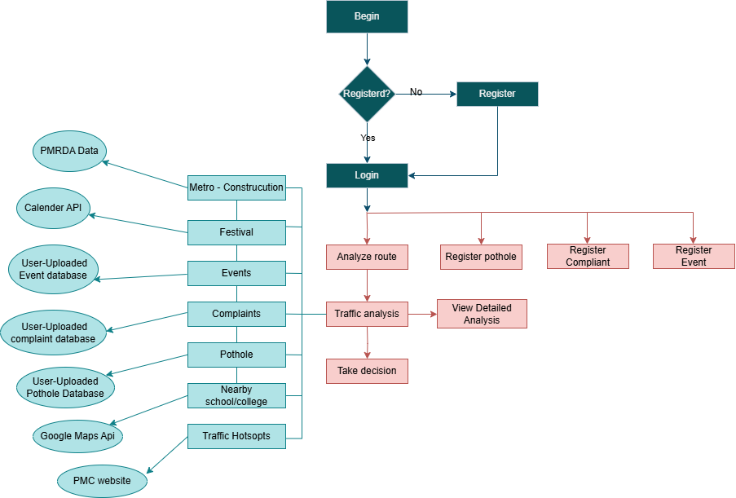

Figure 6.1.1: Architecture of Proposed System

- Figure 6.1.2 depicts the Data flow of system.

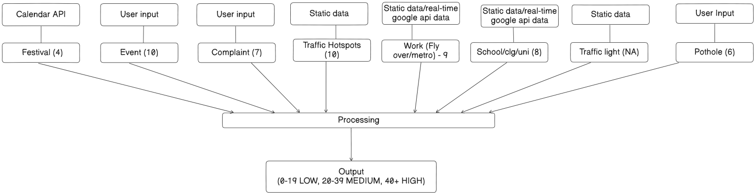

Figure 6.1.2: Data Flow Diagram

- Following Figure 6.1.3 displays System Architecture

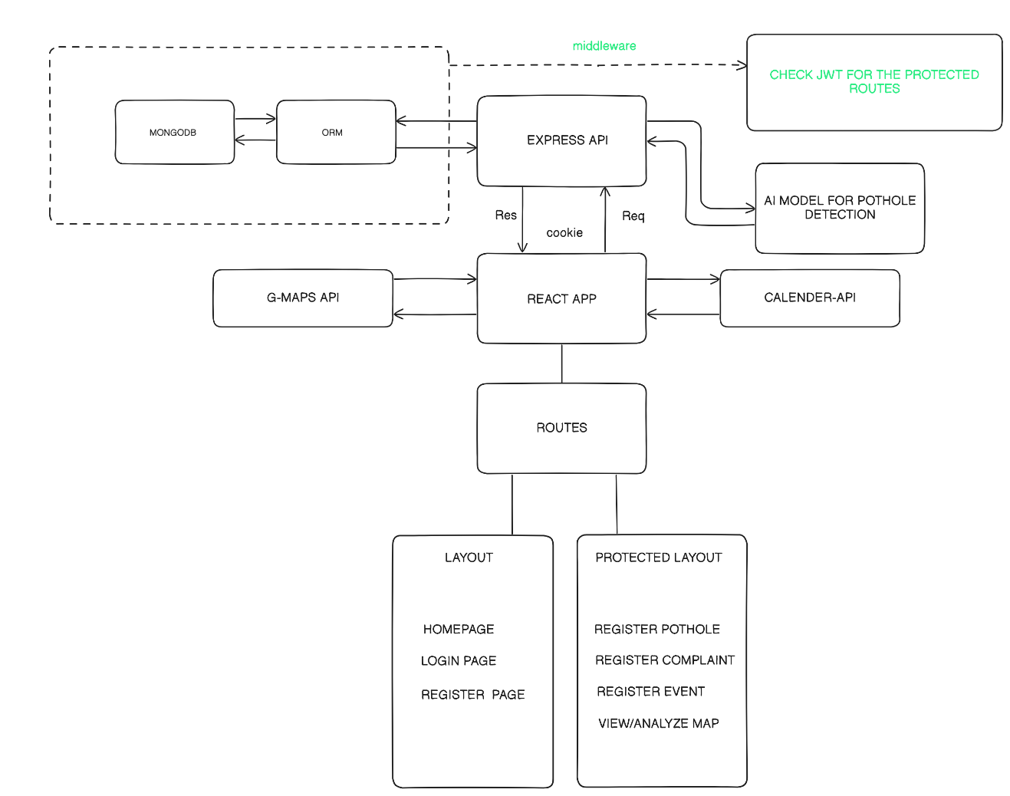

Figure 6.1.3: System Architecture

This implementation provides a robust, scalable, and user-friendly system for traffic analysis, empowering users to contribute to incident reporting and access real-time data for efficient navigation in urban areas.

2. DEVELOPMENT AND TESTING

For our project, we implemented the Agile methodology to ensure efficient and iterative development. Each sprint was planned to last one week, allowing us to set focused, manageable goals and adapt to any changes swiftly. At the end of every sprint, we conducted a review, merged completed code, and outlined the tasks for the upcoming week. GitHub served as our primary tool for version control, helping us collaborate smoothly on both the backend and front-end. This approach facilitated continuous integration, teamwork, and rapid issue resolution throughout the project.

GitHub
GitHub is the most popular web platform for hosting and managing source code repositories. Multiple developers can work on the same project simultaneously without any hassle. We used GitHub to keep track of our source code for Backend and Frontend.

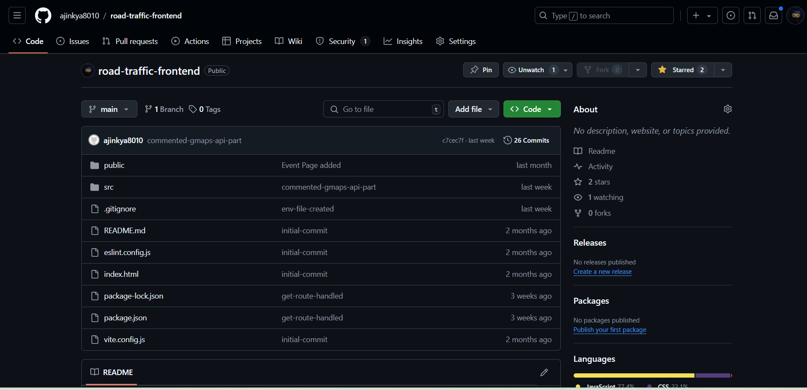

Figure 6.2.1: GitHub repository for Frontend

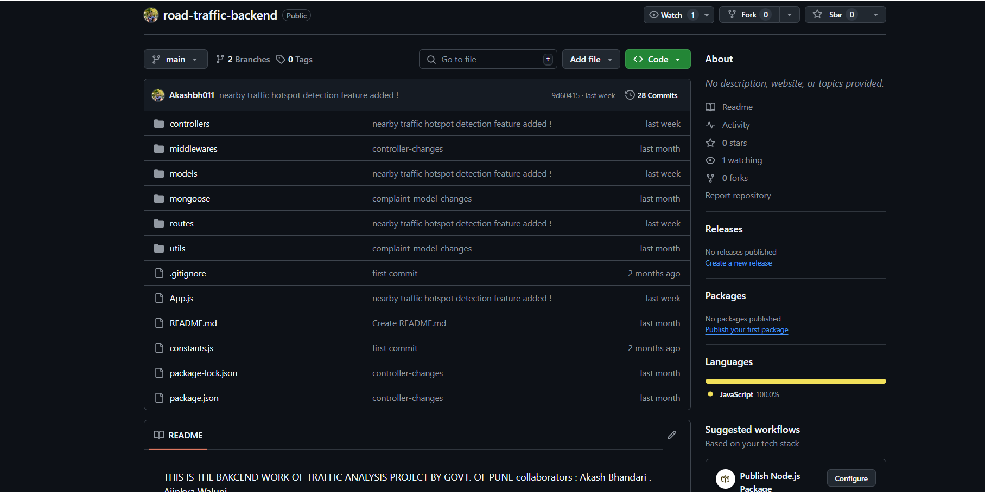

Figure 6.2.2: GitHub repository for Backend

3. RESULTS

The web application consists of several pages namely, Login/Authorization page and the Home page, admin page, complaint registration page, pothole registration page and analyze page.

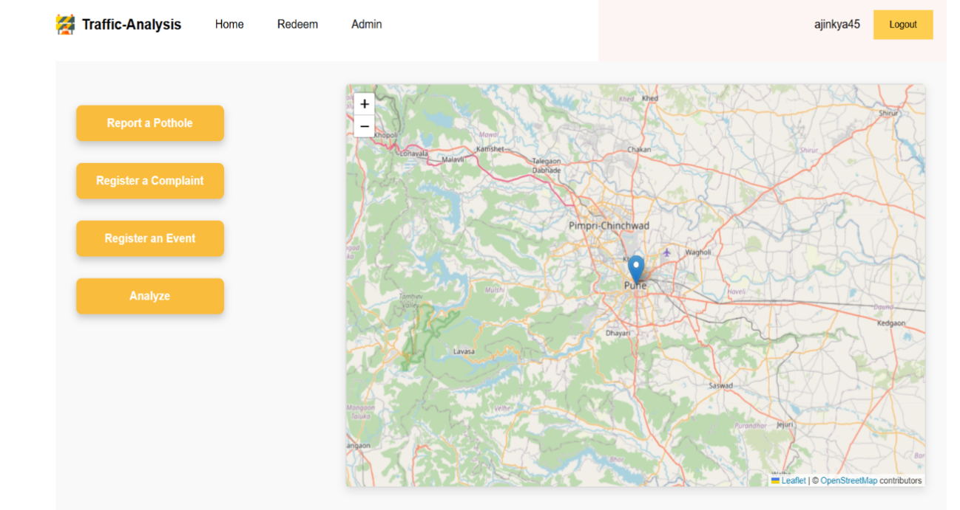Figure 6.3.1: Home Page

Figure 6.3.2: Reward Page

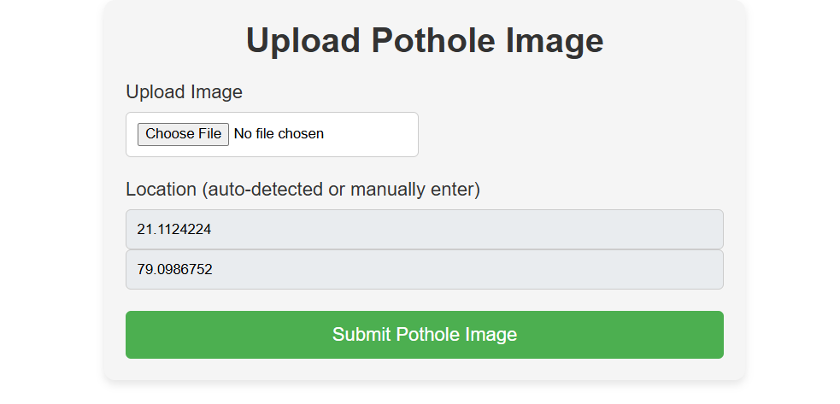
Figure 6.3.3: Pothole Registration Page

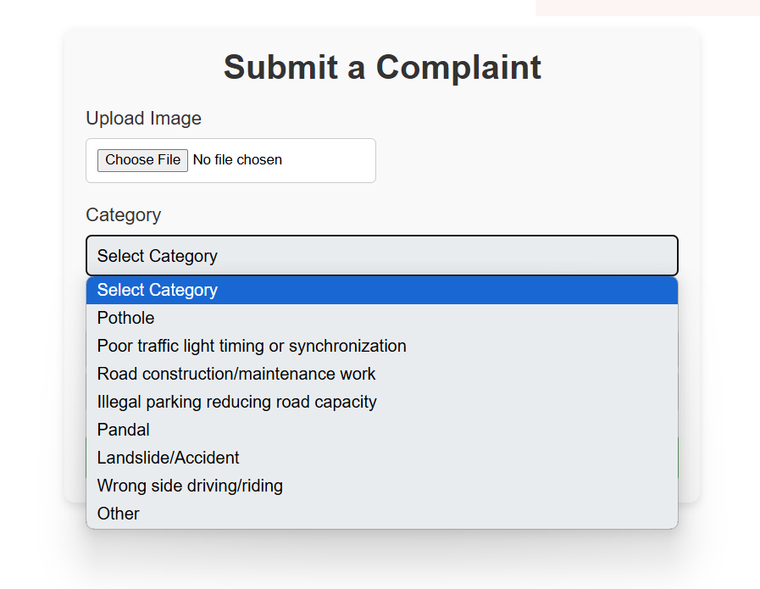

Figure 6.3.4: Complaint Registration Page

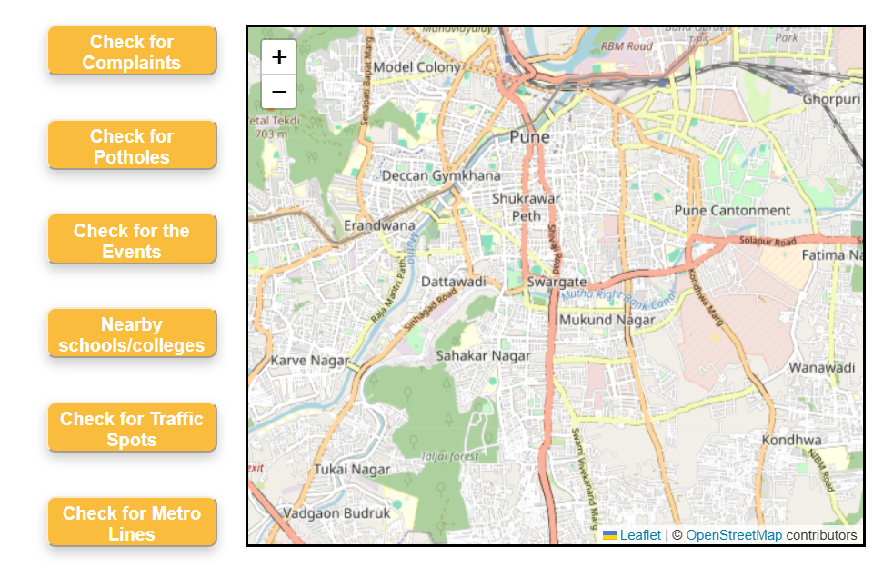
. Figure 6.3.5: Route Analysis Page (State-1)

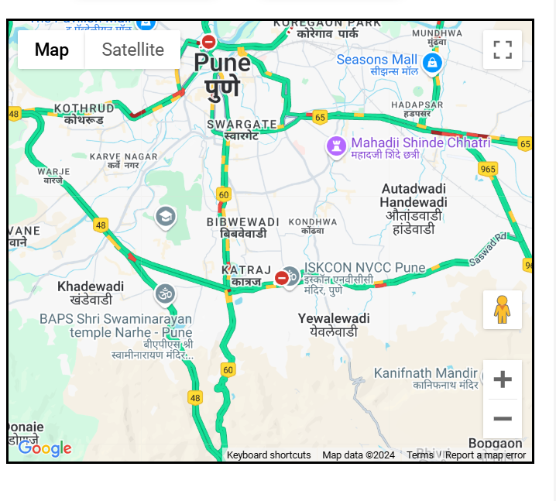
Figure 6.3.6: Route Traffic Map

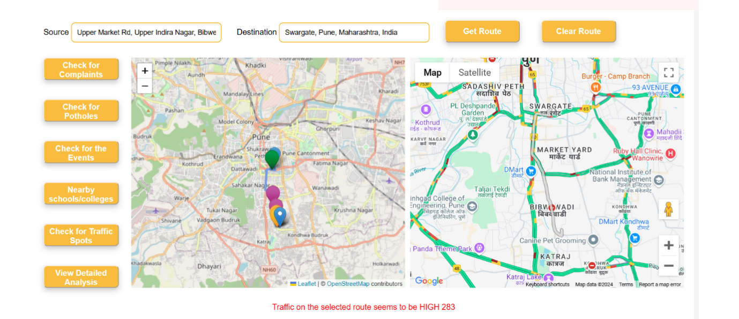

Figure 6.3.7: Display after clicking get route button

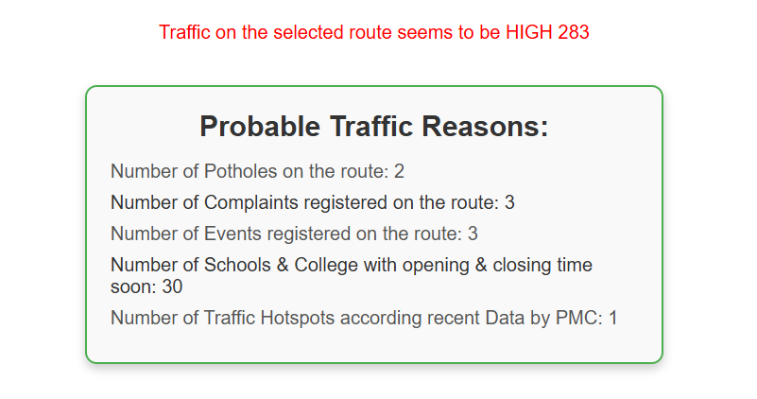
Figure 6.3.8: Detailed analysis for traffic

4. COMPARATIVE EVALUATION

To implement the Register Pothole feature, a classification model was developed to determine whether an uploaded image contains a pothole. Various models were trained and evaluated to achieve the best accuracy and performance for this task. Below is a comparative analysis of the models used

Model name | Hyper-parameters | Accuracy | Trainable layers
- ResNet-50 | Trainable parameters – 7,883,265 | Test Loss – 34.9  Test Accuracy – 87.17% | 5
- Mobile-Net | Trainable parameters – 1,026,001 | Test Loss – 8.7%  Test Accuracy: 96.64% | 10

Table 6.4.1: Result comparison of ResNet-50 and Mobile-Net on Pothole dataset

To implement the Register Pothole feature, a classification model was developed to determine whether an uploaded image contains a pothole. Various models were trained and evaluated to achieve the best accuracy and performance for this task. Below is a comparative analysis of the models used

Functionality | API-used
Traffic display | Google-Maps-API
Map-display | OpenStreetMap-API
Nearby-Places | Google-Maps-API
Route-Display | OpenStreetMap-API

Table 6.4.2: Functionality and corresponding APIs used

The table below outlines the optimization techniques employed in the project along with their respective outcomes. These optimizations enhance the efficiency, responsiveness, and performance of the application by reducing delays, ensuring smoother API interactions, and minimizing redundant operations.

Optimization | Result
- Batch Filtering of Route Points | Reduced response time by 80 seconds
- Rate Limiting with setTimeout | Smooth API usage across multiple request
- Caching with seenPlaceIds | Eliminates redundant API requests for already processed places.

Table 6.4.3: Optimization for Nearby places’ functionality and corresponding result

5. CHALLENGES

1. Data Accuracy and Reliability: Gathering accurate and up-to-date traffic and incident data can be challenging. Any inaccuracies in location, severity, or timing of incidents could impact the reliability of the portal and affect users’ trust in the system.

2. Integration with Multiple APIs: The portal relies on various APIs, such as OpenStreetMap and Google Maps, which may have different data formats and rate limits. Managing these dependencies and ensuring seamless integration can be complex, especially when handling large amounts of traffic data.

3. Scalability and Performance: As the number of users and the volume of data increases, ensuring that the system remains responsive and scalable is a challenge. Efficient data storage, retrieval, and processing, especially for real-time traffic updates and map rendering, are critical for a smooth user experience.

4. Security Concerns: Allowing access to the system from outside the local network through port forwarding opens security risks, such as unauthorized access or data breaches. Ensuring that data and user interactions are protected requires robust authentication, encryption, and firewall configurations.

5. Mapping and Geospatial Accuracy: Accurately displaying and tracking complaints, traffic incidents, and road conditions on the map within a specific range can be challenging, especially with large datasets. Handling geographic calculations for features like route planning and proximity filtering requires careful implementation to avoid performance issues.

6. User Interface Complexity: Building a user-friendly interface that enables users to interact with various features, such as incident reporting, route planning, and viewing traffic data requires careful UX design. Simplifying complex operations while maintaining functionality can be a challenge in web applications.

7. Data Privacy: Collecting and storing user location and incident data in MongoDB Atlas raises privacy concerns. Compliance with data protection regulations (such as GDPR) is essential, especially if the application is accessible beyond internal city use.

8. Handling Large Media Files: Storing and retrieving media files (like images of road incidents) on Cloudinary adds complexity, especially with limited storage and bandwidth constraints. Efficiently managing these files while balancing quality and speed is a challenge for both backend and frontend operations.

9. Real-Time Data Synchronization: Ensuring that real-time traffic data and updates from users are synchronized across all users and devices can be challenging, especially with a high number of concurrent users. Implementing real-time notifications and updates requires robust WebSocket or polling mechanisms.

10. Maintenance and Support: Given the potential scale of this project, maintaining and updating the system, handling API updates, and providing technical support for end-users is an ongoing challenge that requires consistent effort and resources.

6. FUTURE SCOPE

There is good scope for improving the current solution for Traffic analysis.

- Advanced Data Analysis on Traffic and Incident Data
- Description: Machine Learning (ML) algorithms could be applied to traffic and incident data to provide in-depth insights and analytics. This could include identifying patterns such as high-risk areas, peak congestion times, and recurring incidents. Additionally, predictive models could forecast future traffic conditions and recommend preventive measures.
- Potential Insights for Users:
- High-Frequency Incident Areas: Analysis of hotspots where accidents or pothole reports frequently occur.
- Congestion Prediction: Prediction of traffic congestion based on historical data, weather conditions, and time of day.
- User Behavior Insights: Understanding how users interact with the system, such as the most accessed routes and incident reporting trends.
- Implementation Strategy*: Data preprocessing, clustering algorithms, and time-series forecasting models could be used for these analyses. The results would be accessible to end-users via dashboards on the front-end.

- User-Based Partitioning of Incident Reports and Traffic Data
- Description: Allowing users (e.g., municipal employees, contractors, and residents) to create separate partitions for data within the MongoDB database would enhance data organization and privacy. Each user or user group could have a designated partition where they store and access relevant traffic reports, incidents, and analytics.
- Security and Data Management: This feature would provide greater data privacy by isolating data access according to user permissions. Additionally, this approach would improve data management and organization, making it easier to retrieve and analyze data.
- Usage Example: Contractors could have a separate partition for tracking road maintenance activities, while residents could access data on local traffic conditions and incident reports specific to their neighborhood.

- Real-Time Incident Severity Detection with AI
- Description: Utilizing computer vision and deep learning, the portal could assess the severity of incidents (e.g., pothole size or accident impact) based on image data provided in reports. This would help prioritize incidents based on urgency and facilitate quicker responses.
- Implementation Strategy: Images uploaded with incident reports could be processed using deep learning models (like CNNs) to classify or quantify the severity of the incident. For example, pothole images could be analyzed to estimate depth and surface area, helping prioritize repairs.
- Potential Impact: This feature would aid municipal authorities in allocating resources more effectively by addressing the most critical issues first.

- Real-Time Traffic Alerts and Route Optimization
- Description: By using real-time data from external APIs (e.g., Google Maps, OpenStreetMap) and user reports, the portal could offer traffic alerts and suggest optimized routes based on current traffic conditions. Users could receive notifications about nearby incidents, road closures, and alternate routes.
- Implementation Strategy: Integrate WebSocket or similar real-time communication protocols to push updates instantly to the frontend. This would ensure that users receive alerts without needing to refresh the page.
- Benefits: Real-time alerts would enhance the user experience, providing commuters with timely information to avoid congested areas and reducing travel time.

These advanced features would significantly enhance the PMC Traffic Analysis Portal's functionality, enabling it to offer a comprehensive solution for traffic monitoring, analysis, and management. The implementation of these features would require careful consideration of security, data management, and user experience but would position the portal as a powerful tool for municipal traffic analysis and incident management.

CONCLUSION

In conclusion, the PMC Traffic Analysis Portal provides a robust and scalable solution for monitoring and managing traffic conditions and road incidents within the city. Leveraging a modern tech stack that includes Node.js, Express.js, MongoDB, Cloudinary, React, and mapping APIs, the portal empowers municipal authorities and residents alike with real-time traffic insights, incident reporting, and optimized routing capabilities. Future enhancements, such as advanced data analysis, remote access with secure port forwarding, real-time alerts, and integration with emergency services, could further improve traffic flow, safety, and resource allocation. As cities grow, this portal can evolve into a critical tool for proactive urban traffic management and efficient infrastructure maintenance, ensuring safer and smoother travel for all.

REFERENCES

[1] Ahmed, Khaled R. & Kharel, Subash. (2021). Potholes Detection Using Deep Learning and Area Estimation Using Image Processing. 10.1007/978-3-030-82199-9_24.

[2] Grepon, B., Margallo JC, Maserin, J., Dompol, R., (2023). RUI: A Web-based Road Updates Information System using Google Maps API. International Journal of Computing Sciences Research, 7, 2253-2271. https://doi.org/10.25147/ijcsr.2017.001.1.158

[3] Google Maps Developers, “Google Maps integration,” [Online]. Available: https://developers.google.com/maps. [Accessed: Nov. 17, 2024].

[4] OpenStreetMap, “OpenStreetMap integration,” [Online]. Available: https://www.openstreetmap.org/. [Accessed: Nov. 17, 2024].

[5] M A T Pratama and A T Cahyadi. (2020). IOP Conf. Ser.: Mater. Sci. Eng. 879 012133.

[6] Sourabh Mahadev Malewade, Archana Ekbote. "Performance Optimization using MERN stack on Web Application." International Journal of Engineering Research & Technology (IJERT), ISSN: 2278-0181, IJERTV10IS060239. http://www.ijert.org, Vol. 10, Issue 06, June-2021.

[7] Nafea, Ali & Ibrahim, Hassan. (2023). Online Destinations Map using Google Maps API Based on the Private Database. International Journal of Information Technology and Computer Engineering, 35-39. 10.55529/ijitc.35.35.39.

[8] Anuj Joshi. "PROS AND CONS ANALYSIS OF MERN STACK FRAMEWORK FOR WEB DEVELOPMENT." International Journal of Research Publication and Reviews, Vol. (5), Issue (5), May (2024), Page – 5638-5642.

[9] Node.js Foundation, “Node.js Integration,” [Online]. Available: https://nodejs.org/docs/latest/api/. [Accessed: Nov. 17, 2024].

[10] Meta, “React Integration,” [Online]. Available: https://legacy.reactjs.org/docs/getting-started.html. [Accessed: Nov. 17, 2024].

[11] Hasabi, R., Kurniawan, R., Sugiarto, M., Wahyuni, R. N. T., & Nurmawati, E. (2024). Urban traffic congestion and its association with gas station density: Insights from Google Maps data. Indonesian Journal of Electrical Engineering and Computer Science, 35(3), 1618-1626. DOI: 10.11591/ijeecs.v35.i3.pp1618-1626.

[12] Lin, P., He, Y., Pei, M., & Yang, R. (2022). Data-driven spatial-temporal analysis of highway traffic volume considering weather and festival impacts. Travel Behaviour and Society, 29, 95–112. DOI: 10.1016/j.tbs.2022.06.001.

[13] Essien, A., Petrounias, I., Sampaio, P., & Sampaio, S. (2021). A deep-learning model for urban traffic flow prediction with traffic events mined from Twitter. World Wide Web, 24(4), 1345–1368. https://doi.org/10.1007/s11280-020-00800-3.

[14] Abbasi, M., Shahraki, A., & Taherkordi, A. (2021). Deep Learning for Network Traffic Monitoring and Analysis (NTMA): A Survey. Computer Communications, Vol. 170, pp. 19–41. Elsevier B.V. https://doi.org/10.1016/j.comcom.2021.01.021.

[15] Medina-Salgado, B., Sánchez-DelaCruz, E., Pozos-Parra, P., & Sierra, J. E. (2022). Urban traffic flow prediction techniques: A review. Sustainable Computing: Informatics and Systems, 35. https://doi.org/10.1016/j.suscom.2022.100739.

[16] Olaniyi, O. O., Okunleye, O. J., & Olabanji, S. O. (2023). Advancing Data-Driven Decision-Making in Smart Cities through Big Data Analytics: A Comprehensive Review of Existing Literature. Current Journal of Applied Science and Technology, 42(25), 10–18. https://doi.org/10.9734/cjast/2023/v42i254181.

[17] SafeGraph, “Geospatial Data Visualization Integration,” [Online]. Available: https://www.safegraph.com/guides/visualizing-geospatial-data. [Accessed: Nov. 17, 2024].

[18] Cloudnary, “Cloudinary Integration,” [Online]. Available: https://cloudinary.com/. [Accessed: Nov. 17, 2024].

[19] MongoDB Inc., “MongoDB Integration,” [Online]. Available: https://www.mongodb.com/atlas. [Accessed: Nov. 17, 2024].

